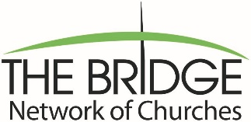

The Bridge Network of Churches Scholarship Program
Release Information Form
A copy of this form will be kept on file in the Bridge Network of Churches’ office and a copy sent to your school. ALL INFORMATION WILL BE TREATED BY the Bridge Network of Churches IN A CONFIDENTIAL MANNER. Virginia state law requires the student’s permission for the release of this information.
School I plan to attend:
School Address:
City: State: Zip:
Telephone:

I, , a recipient of a scholarship from the Bridge Network of Churches, do hereby give permission to my school to release any information requested by the Network related to my academic performance during the 2024/2025 academic year. This information will only be requested by the Network for the purpose of determining scholarship eligibility.
Thank you.
Applicant Signature:
Parent or Guardian Signature:
Date:

THE COMPLETED SCHOLARSHIP APPLICATION and REQUESTED MATERIALS MUST BE POSTMARKED/SUBMITTED NO LATER THAN APRIL 10, 2024.

