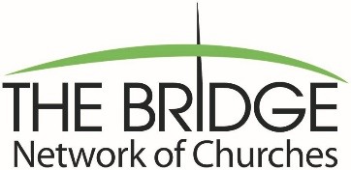

SCHOLARSHIP APPLICANT PLEDGE
I pledge the information which I have provided is accurate to the best of my knowledge. I have read the guidelines and requirements for a The Bridge Network of Churches Scholarship and promise that I will do everything in my power to abide by the requirements stated. If I find that I cannot abide by these requirements, I will immediately notify the BNoC.
Applicant Signature:
Parent or Guardian Signature:
Date:
CHURCH OFFICER APPROVAL (NON-FAMILY SIGNATURE REQUIRED):
Signature:
Pastor Associate Pastor Church Clerk Treasurer Deacon Chair

The Bridge Network of Churches will hold confidential any information provided on the application and will use the information only for the purposed of determining scholarship eligibility. If awarded a scholarship, the BNoC reserves the right to publish the recipient’s name and likeness in reporting the work of the BNoC to our constituency.

